CV
TAMAR MAGHRADZE
Personal details
Date of Birth: 24.01.1986
Address: chkondideli street #22 Tbilisi, Georgia.
mob.: +995 593 92 24 19
E-mail: tt.maghradze@yahoo.com

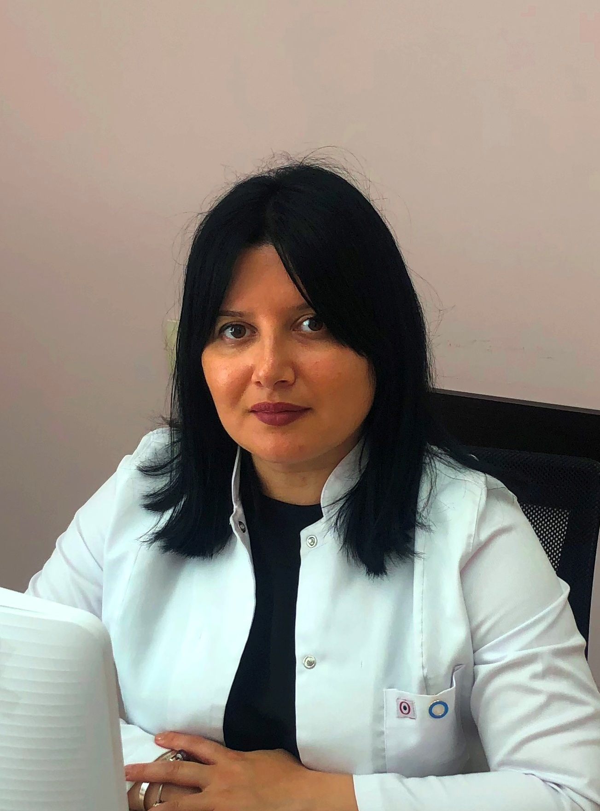

Education:
2019- up Phd-Student Tbilisi State University
2012-2016- Tbilisi state medical University –Residency- speciality -Endocrinology
2005 – 2011 Tbilisi state medical University-Faculty of medicine
2002- 2005 Tbilisi State Medical University-Faculty of Foreign language(secondary faculty)
2016- State Certificate-speciality- Endocrinology
2019- State Certificate-speciality –Nutrientology
Work Experience:

2019-up „“Clinic-Medison”- MD, Endocrinologist

2018-up “National screening center”- MD, Endocrinologist

2016-up - “National Center for Diabetes Research”- MD, Endocrinologist

2016-up -Magazine -“Diabetes and Health”- Member of the Editorial Board; Leading topic- "Diabetic Neuropathy"

2016-2019 -“National Cancer Center”- MD, Endocrinologist

2014-0216- Academic clinic-’’ Diakori” - Junior Doctor
2013-2014 - "David Tatishvili Medical Center" – Insurance Companies Relations Manager
2012-2013- The resort "Sairme" - Head of Quality Management Deapartment (clinic and spa)
2011-2012- Insurance company ''vesti”- Medical Expert
2010-2015 IFMSA (International Federation Of Medical Students Association)- Head of the Standing Committee on Professional Exchange (SCOPE)
2010- Insurance Company “Irao” -Insurance Agent
2009- Tvilisis State Medical University, Al. Aladashvili National University Hospital (Intern)
2007 - Tvilisis State Medical University N. Kipshidze national University Hospital (Intern)
2007 – 2015 Non-governmental organization “Georgian Young Medic’s Union”
Internships, Trainings, Conferences:
2019- 6th Congress of Georgian Society of Cardiology -"Modern Chellenges of Cardiology" Certificate of Attendance -8 june 2019,Tbilisi,Georgia
2019-Georgian Association of Endocrinology and Metabolism and European Society of Endocrinology –“International Conference on Geriatric Endocrinology- Certificate of Attendance-25-26 May 2019,Tbilisi, Georgia
2019-National Institute of Endocrinology-„Thyroid Meeting”- Certificate of Attendance-4 March 2019,Tbilisi, Georgia
2018-Georgian Association of Endocrinology and Metabolism-“International Workshop on Vitamin D ”- Certificate of Attendance-24 November ,2018,Tbilisi, Georgia
2018-Georgian Association of Clinical Endocrinologists “-postgraduate Course”Clinical Update in Endocrinology”- Certificate of Attendance-5-6 october, 2018,Tbilisi, Georgia
2018- “Europian Association for the Study of Diabetes (EASD)-Diabetic Neuropathy Study Group- Certificate of Attendance-4-7 September, 2018,Rome,Italy
2018-Training-“Stop Smoking and Treatment”-Organized by company-„PFIZER”- Certificate of Attendance- June 2018,Tbilisi, Georgia
2018-Bokhua Memorial cardiovascular centre-“Modern approaches and standards of treatment of heart failure” Certificate of Attendance- May 2018,Tbilisi, Georgia
2018- “EASD- Postgraduate Course on Clinical Diabetes ” Certificate of Attendance, Participation as faculty member 10-12May 2018 , Tbilisi, Georgia
2018- Georgian Physicians Postgraduate Association, International Associaciation Neurodiab,Georgian Union of Diabetes and Endocrine Associations,conference” 1-st young Investigators Meeting “Diabetic Neuropathy”-Moderator Prof.Solomon Tesfaye,MD,FRCP,UK .- Certtificate May9,2018, Tbilisi,Georgia
2018- Georgian Physicians Postgraduate Association,Academic Clinic-‘’DIAKOR”-International Diabetes Federation Centre of Education, conference ‘Specific Types of Diabetes in Clinical Practice”-Certificate,April 3,Tbilisi,Georgia
2018-"Current Issues in thyroidology, Meeting with ETA Experts" - Certificate. 10 March .2018 Tbilisi Georgia
2018- Tbilisi State Medical University, Clinic "Enmedicine" - "Endoscopic Surgery of Thyroid Gland, Modern Approaches" – Certificate.
2017- “EASD- Postgraduate Course on Clinical Diabetes and its Complications” Certificate of Attendance 27-29 october 2017,Prague Czech Republik.
2017- 5th Congress of Cardiology Society of Georgia "Current Issues of Cardiology" Certificate
2017- Diabetes Education Study Group (DESG) Award "for the implementation of DIA link modules for the Diploma Medical Education Program
2016- State certificate of Endocrinology
2016-Europian Thyroid Association Grand Course(European Thyroid Association) Certificate
2016- An Update on Management of Adult Obesity-EASO-OMTF Teaching Course.(European Association for the Study of Obesity) Certificate
2015-2th Health International Annual Conference (Georgian International Medical and Public Health Association, GIMPHA) Certificate
2012- The prevention of Medical treatment for HIV / AIDS related stigma and discrimination (Global projects implementation centre) Certificate
2011-“ Modern aspects of diagnosis and treatment of oncology diseases” (Georgian Young Medic’s Union” and “National Center for Diabetes Research” ) Certificate
2009- Inpatient facilities management issues. Fund "health" of the International Scientific Conference. Certificate
2005- Association "support" for HIV / AIDS (AIDS Center) Certificate

Reports:

•International Diabete Federation(IDF)- Abstract -“Association between diabetic peripheral neuropathy (DPN) and Hypertiglyceridemia in patients with type 2 diabetes in Georgia”- 2-6 December 2019 ,Busan ,Korea (Poster number-0692)

• “Europian Association for the Study of Diabetes (EASD)-Diabetic Neuropathy Study Group- Poster Presentation :“Effect of fenofibrate treatment in patient with diabetic peripheral neuropathy and hypertrigliceridemia in patient with type2 diabetes in Georgia” 13-16 September, 2019,Sitges-Barcelona,Spain

•Georgian Physicians Postgraduate Association ”-Reports:”Diabetic Hand Syndrome-Less Known Complication”; “Hyperglycemia and increase of infections”-9-17 February 2019 ,Bakuriani,Georgia

• “Europian Association for the Study of Diabetes (EASD)-Diabetic Neuropathy Study Group- Poster Presentation :“Illustrating Problems Associated with Diabetic Foot in Georgia –Clinical Case Study.-4-7 September, 2018,Rome,Italy

• “Europian Association for the Study of Diabetes (EASD)- Postgraduate Course on Clinical Diabetes-Yong Speaker-”Clinical Case Report on Acute Pancreatitis with concomitant T2DM and Hypertriglyceridemia,10-11 May,2018 Tbilisi,Georgia

•Georgian Physicians Postgraduate Association, Georgian National Diabetes Association-1st Young Investigators Meeting, Report:”Lower Extremity Complications of Diabetes State of Diabetic Food Care in Georgia” 9 May 2018 Tbilisi,Georgia

•Georgian Physicians Postgraduate Association ”-Report: ”Patiant newly diagnosed asymptomatic hyperglycemia,Differential Diagnostics Among of Rare forms of Diabetes ”-9-17 February 2018 ,Bakuriani,Georgia

•International Diabete Federation(IDF)- Abstract - Importance of Developing Podiatric Service in Georgia – Case Report Illustrating Problems Associated with Diabetic Foot -4-8 December 2017 ,Abu Dhabi,United Arab Emirates

•Georgian Physicians Postgraduate Association ”- Report :”Diabetic Neuropathy ”-February 2017 ,Bakuriani,Georgia

•European Thyroid Association(ETA)-Abstract-” The correlation of thyroid auto-immunity in type 1 diabetes mellitus. 3-6 September,2016 Kopenhagen,Denmark

Published Articles:

Magazine -“Diabetes and Health”- article-“ Permissible physical activity in school-age children with type 1 diabetes” N 22. pp.20-21; "Diabetes and physical exercise" N 22. pp.22-23; "Medications That Increase Glucose": N 22. pp.50. April 2020

Magazine -“Diabetes and Health”- article-“ Numerous Complications in Type 1 Diebetes in young patients”;“Diabetic Hand Syndrome“- N 21. pp.33-34; March 2019

Georgian Medical News- article--”Clinical Case Report on Acute Pancreatitis with concomitant T2DM and Hypertriglyceridemia” - ISSN 15112-0112; N0 4(277) pp.38; April 2018

Magazine -“Diabetes and Health”- article- “Avoid Amputation”- N 20. pp.26; March 2018

Languages:
- Native Georgian
- Well in English
- Fluent in Russian (spoken/written)
Interests: Reading, Skiing, Meeting interesting people

