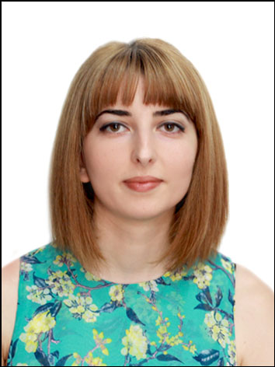
Curriculum Vitae
Sophio Jojua

First name | Sophio
Surname | Jojua
Date of birth | 07.06.1990
Address | Kldiashvili #11
Phone number | 598 80 22 33;
g-mail | Sjojua22@gmail.com
Fafebook, Skype | Sophie jojua, skype: sopo-sopo7773

Education And Training

Secondary Education

school(City and school № ) | Date of Start | Date of Graduate
Senaki #1 public school | 1997 | 2009

High Education

Educational Institution | Faculty | Degree | Date of Start and Graduate
1.Sokhumi State University | Faculty of Humanities | Bachelor’s  degree | 2009-2013

2.Sokhumi State University | European lenguages and literature | Master’s degree | 2014 -2016

Achievements:

-Certificate in studying English(2012 წ);

-Certificate in studying Computer programs(2013)

-Sokhumi State University Bachelor’s Diploma With Honours. Faculty of Humanities (GPA 3,6) (Diploma #000983);

-Certificate in studying English. Level C1(2015)

-Sokhumi State University Master’s Diploma With Honours. Faculty of Humanities (Diploma#000764);

-Certificate in studying General English. Level C1 Oxford Academy(2018)

- Certificate (CELTA) Certificate In Teaching English to Speakers of Other Languages (2021წ)

Pedagogical Experience

Educational Institution | Name of position | Date of Start and Graduate
Oxford Academy | English Teacher | I have been working since 2016.
Private school kandeli | English Teacher  Head of the Department of Foreign Languages | 2016-2018(2) I have worked for 2years.
High school of Eqvtime Tayaishvili | English Teacher | I have been working since 2018

Additional Information: 6years of experience working as a tutor

Computer programs:Microsoft Word, Mc excel, Mc power-point, Adobe Photoshop, Internet, Outlook.

Knowledge of Languages
Languages | Levels:
Languages | LevelsA1A2 | Basic user B1|B2 | Proficient user C1 | Mother tongue
1.Georgian |  |  |  | X
2.Russian | X
3.English |  |  | X

