**Curriculum Vitae**

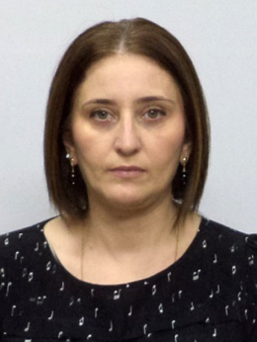

**Khatuna Khomeriki** 33001008617 Date of birth: 18/12/1970

#8a Kikvidze St. place of birth: Ozurgeti (Makharadze)

4600 Kutaisi, Georgia Georgian citizen

Phone: (+995) 577 28 34 43

E-mail: khatuna_khomeriki@yahoo.com

**Education**

**1990-1996 Tbilisi State University (TSU)**

Bachelor in law (LL.B.); Master of Laws (LL.M)

**Work Experience**

02.04.2007-present Judge at Kutaisi Appeal Court

2015 - present Kutaisi State University

2002-2006 Judge at Kutaisi District Court

2001-2002 Assistant to Imereti District Attorney

2000-2001 Lawyer at Kutaisi internal revenue office

**Language**

Georgian Mother tongue

Russian Fluent

English pre Intermediate

**IT Knowledge**

Microsoft Office Good

Microsoft Office Excel Good

**Trainings attended:**

* Training "Children`s Rights";
* Training "Current Issues in Administrative Proceedings";
* Seminar "Property Law Related Issues (problematic issues related to land disputes, disputes related to real estate registration)" held by the Higher School of Justice with the support of the German Society for International Cooperation (GIZ);
* Seminar - "Specifics of Construction Disputes";
* Special training course on the topic: "Juvenile justice, methods of dealing with minors and other related issues";
* Seminar "Ensuring Effective Access to Justice for People with Disabilities";
* Seminar "Tax offenses and Tax Disputes";
* Training in Strasbourg and Paris under the auspices of the European Arbitration Chamber on the topic "European Human Rights Protection and Alternative Dispute Resolution";
* Workshop organized by the United Nations Development Program (UNDP)and the German Society for International Cooperation (GIZ) on election issues;
* Seminar on Tax Code related issues;
* Seminar "Judicial Conduct and Ethics";
* Seminar on issues related to the Administrative Proceedings Code of Georgia;
* Seminar "Communication Standards in Court Proceedings";
* Seminar "Enforcement of decisions";