Curriculum Vitae

Personal information:
Sophie Katcharava  DOB: 15.09.1979  Nationality: Georgian  Marital status: Married  Contact details:  Mail:s.katcharava@ardi.ge  Mob: +995597972297 | 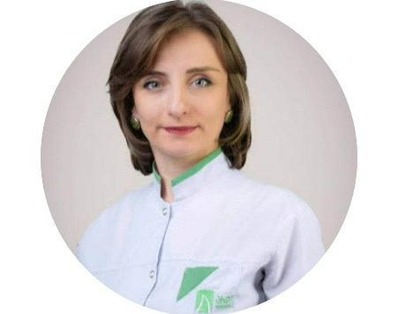
Working Experience:

2003–2006 General Profile Doctor at Clinic “Abkhazeti”
2006-2009 Doctor Therapist at Clinic “Abkhazeti”
2006- 2019 Doctor Therapist at M.asatiani Psychiatric and Drug Prevention Center
2010-2011 Doctor Therapist at Clinic IMSS
2011-2013 Doctor Therapist at Insurance Company “Aldagi BCI”
2013-up to present Doctor Therapist at Insurance Company “Ardi”

Education
Diplomas & Certificates

1996-2002 Bachelor’s Degree of Tbilisi Medical Academy
2002 Therapeutic Cardiology –Moscow state Medical Academy
2004 Arrhythmia & Clinical Cardiology – Cardiologic Clinic “Guli”
2005 BLS<ALS<BTLS<ATLS Programme at Emergency Center
2006 State medical certificate of internal disease
2012 State medical certificate of family doctor (JP)

Languages:

Georgian –Russian – English

Advantages:

Good organizational skills, High sense of responsibility, Team worker, promptly adaptable to the new environment

