Curriculum Vitae

NATIA TKESHELASHVILI
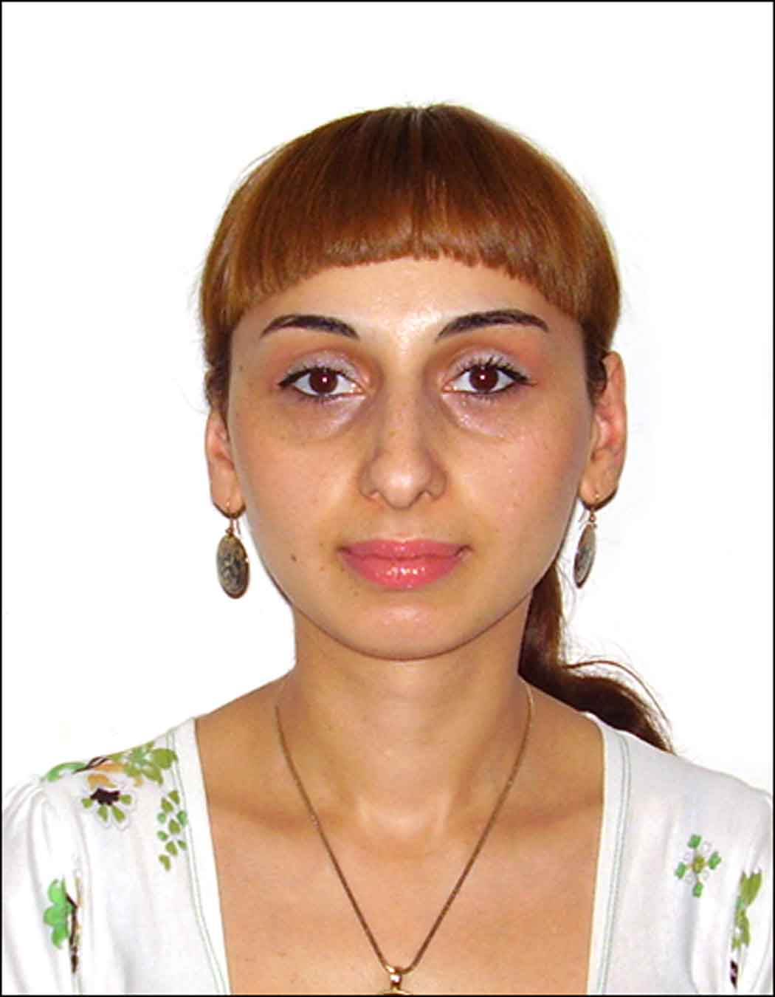
PERSONAL DETAILS
Full name: Natia Tkeshelashvili
Nationality: Georgian
DOB: 28.02.1982
Marital status: Married
Address: M. Meskhi 52; Tbilisi; Georgia.
Tel.: +99-5-32964698
Mob.: +995-551822802
E-Mail: nt8228@inbox.ru; nt8228@gmail.com

Education

- 1999-2003 - Tbilisi State Medical University;
Faculty of Foreign Languages.
- 1999-2005 - Tbilisi State Medical University;
Faculty of General Medicine.
- 2007-2011-TSMU Institute of Postgraduate Medical Education and Continuous Professional Development-Full Residency Course in Family medicine.
- 2019- TSMU Institute of Postgraduate Medical Education and Continuous Professional Development-Abbreviated Residency Course in Internal medicine.

Work experience

- June 2005 – 10.02.2010 –L.t.d. GPC-company-Pharmacist.
- March 2010-July 2010_ L.t.d. “World Medicine”-Medical Representative.
- 16.08.2010.-04.02.2012.-Joint stock company “My Family Clinic”. Assistant of The Therapeutic Service.
- 09.02.2012.-06.07.2015.-L.t.d. “PSP Insurance”.-Manager of the Medical Center ; Family Physician.
- 06.07.2015.-03.01.2018.-Insurance company “ImediL”. Family Physician.
- 03.01.2018.-17.09.2018.-Insurance company “GBG”. Clinic “Medalpha”. Personal doctor.
- 18.09.2018.-till now-Insurance company “Prime”. Clinic “Medalpha”. Family Physician.
- 01.08.2019.-till now-German Hospital. General Practitioner.

Language skills

- Georgian-native
- English – fluent
- Russian – fluent
- German-poor

Computer skills

- MS Office – advanced.

Other skills

- Driving License

