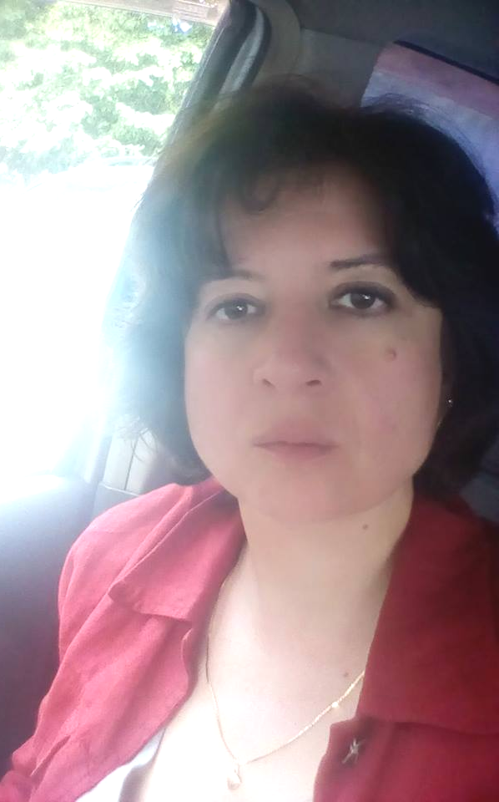
C.V.

First name ,  Last name | Ia  Zedelashvili
Date of birth (number, month - verbally, year) | 28.10.1971
Country | Georgia
Address de jure | Flat 11, Building 12 , Digomi Massive I quartal ,Tbilisi
Address de facto | Flat 11, Building 12 , Digomi Massive I quartal ,Tbilisi
Mobile phone number | 597219449
Email address: | izedelashvili@newvision.ge

Work experience
Start the sequence with the last workplace
Organization |  | Position |  | Period of work
New Vision University |  | coordinator of study process, lecturer, manager of rehabilitation programs |  | 2016 -
Medical center  “Harmony” |  | Endocrinologist, nutritionist |  | 2009 -2011
Medical center  “Sikete” |  | Endocrinologist |  | 2005 -2013
Medical diagnostic and rehabilitation center |  | Endocrinologist |  | 1998 -2001
Zhordania Clinic |  | Gynecologist-endocrinologist |  | 1996-1997
Railway Polyclinic |  | Endocrinologist |  | 1995 -1998
Education; Qualification raising courses; Trainings
Name of the school | Country |  | Faculty; Training/Course name | Degree | The study period
Tbilisi State Medical University | Georgia |  | Medical Faculty | Specialist in medical work | 1988 -1994
Internship (master's degree) | Georgia |  |  | endocrinologist | 1994 -1995
Higher School of Informatics and Businessmen Tbilisi Javakhashvili State University | Georgia |  | international relations | computer scientist  -business man | 1991 -1996
Zhordania Clinic | Georgia |  | Vacuum aspiration abortion, coposcopy, preparation of laboratory samples | Vacuum aspiration abortion specialist | 1996-199
Tbilisi Balneological Resort State Enterprise-Medical Massage School  Avan | Georgia |  | Therapeutic massage | massage therapist | 1998
Training courses for medical workers  People's Friendship University of Russia | Georgia |  | Nutritionology | Nutritionist | 2004

Foreign Languages
Georgian | fluent
Russian | fluent
English | fluent
1

