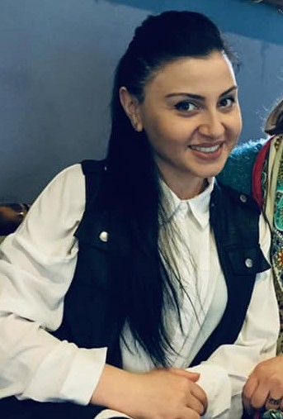

Personal information

Name : Tamari

Surname: Pataraia

E-mail : Pataraia.tamari@unik.edu.ge

Marital status : married

Date of birth: 15.05.1995

Education : Kutaisi Universiti . Faculty of Economics

Academic degree of Bachelor of Engineering

Work experience: microfinance organization Family Credit

Credit manager - (2017-2021year)

Languages :

Georgian language - very well

English language- good

Russian language- good

Turkish language – good

Computer programs:

microsoft office word – good

Microsoft office excell –good

Microsoft office outlook –good

Microsoft office PowerPoint –good