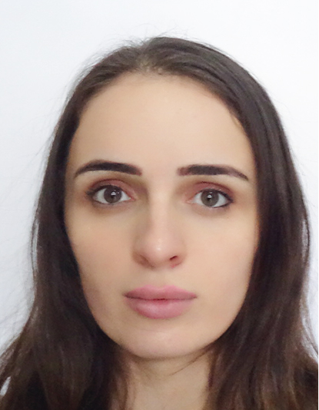Photo

**CV**

**1. Personal Information**

|  |  |
| --- | --- |
| **Surname** | Kurtanidze |
| **Name** | megi |
| **P/N** | 01005026619 |
| **Birthdate (dd/mm/yy)** | 04/12/1992 |
| **Address** | Tbilisi, iosebidze street #61 |
| **Tel:** | +995599088676 |
| **Mail :** | Meg.kurtanidze@gmail.com |
| **Current occupational position** | Tbilisi city medical- head of radiology department |

**2. education**

|  |  |  |
| --- | --- | --- |
| **I** | | |
| **Name of the higher education institution** | Tbilisi state medical university | |
| **Faculty / Specialty** | Medicine | |
| **Date of the enrollment/Graduation** | **Beginning (yy)** | **End (yy)** |
| 2010 | 2016 |
| **Qualification** |  | |
| **II** | | |
| **Name of the higher education institution** | Tbilisi state medical university, Ataturk university(Erzurum, Turkey)- program in Doppler ultrasound | |
| **Faculty / Specialty** | Radiology residency | |
| **Date of the enrollment/Graduation** | **Beginning (yy)** | **End (yy)** |
| 2016 | 2019 |
| **Qualification** |  | |

**3.Foreign languages**

|  |  |  |  |  |
| --- | --- | --- | --- | --- |
| **Level** | **A2<** | **B1** | **B2** | **C1>** |
| **Foreign language** |
| **English** |  |  |  | + |
| **Russian** |  |  | + |  |
| **Turkish** |  |  | + |  |

**4. Computer Skills**

|  |  |
| --- | --- |
| **Program** | **Level** |
| **Microsoft excel** | + |
| **Microsoft word** | + |
| **Microsoft powerpoint** | + |

**5. Professional experience**

|  |  |  |  |
| --- | --- | --- | --- |
| **Date (mm/yy)** | | **Employer** | **Position / duties** |
| **-from** | **-to** |
| 2020 | currently | Tbilisi city medical | Head of radiology department, radiology MD |
| 2020 | currently | Clinic “open heart” | Radiology MD |
|  |  |  |  |
|  |  |  |  |
|  |  |  |  |

**6. Scientific-pedagogical experience**

|  |  |  |  |  |  |
| --- | --- | --- | --- | --- | --- |
| **Date (mm/yy)** | | **Higher Education Institutions** | **Position** | **Study course / Research project** | **Learning step** |
| **-from** | **-to** |
| 2021 | currently | European university | Invitied lecturer | Medicine, dentistry | 1,2,3 |
| 2022(march) | currently | Georgian national university-SEU | Invited lecturer | Medicine | 1,3,4 |
|  |  |  |  |  |  |
|  |  |  |  |  |  |
|  |  |  |  |  |  |
|  |  |  |  |  |  |
|  |  |  |  |  |  |

**7. scientific publications for the last 5 year.**

|  |  |  |  |
| --- | --- | --- | --- |
| **Date** | **Topic of the working theme** | **Scientific Journal** | **Publisher** |
| 19.05.2022 | Post-COVID mesial temporal sclerosis | KCR 2022  42nd KCR Annual Scientific Meeting and  The 16th International Symposium | Korean college of Rheumatology |
| 19.05.2022 | Erdheim-Chester disease mimicking coronary artery disease in a systemic lupus  erythematosus patient | KCR 2022  42nd KCR Annual Scientific Meeting and  The 16th International Symposium | Korean college of Rheumatology |
|  |  |  |  |
|  |  |  |  |
|  |  |  |  |
|  |  |  |  |