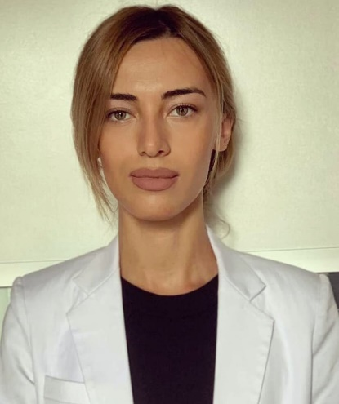

Personal Information

Name and Surname | Mariam Khurtsilava
Date of Birth | 27.08.1992
Personal Number | 60001114141
Address | Kutaisi, Javakhishvili str.#18, fl.43-44
Phone Number | 514 68 50 50
E-mail Address | mariamkhurtsilava92@gmail.com

Education

Years | Name of the Institution | Specialty | Qualification
2010-2014 | Ak.Tsereteli State University | Humanities (English / Russian Language and Literature) | Bachelor
2015-2017 | Kutaisi University | Finance, Banking and Insurance | Master's degree

Other Activities

Years | Organization | Position
2021-2022 | LTD “Kutaisi University” | Administrative Assistant
2022-to present | LTD “Kutaisi University” | Human resources management and case management service specialist
2018-2020 | LTD “Georgian post” | Sales Operator
2016-2017 | kutaisi city hall | Culture Service Specialist
2014-2015 | JSC Liberty Bank | Service Consultant

Participation in Qualification Raising Courses, Seminars, Trainings
№ | Date | Name of training course, seminar | Your status (facilitator, participant)
1 | 2019y. | “Effective communication” | Participant
2 | 2014y. | MFX Broker | Participant
3 | 2013y. | European Law Students Association Kutaisi - Seminars on the topic - Step towards a successful future | Participant
4 | 2010y. | Gender and Civic Education | Participant
5 | 2009y. | Management, Leadership, The Art of Debate, Communication, Conflict Management, Public Speaking, Democracy | Participant
6 | 2021 | Teamwork (team process management) training course | Participant
7 | 2022 | Primary emergency medical care | Participant
8 | 2022 | Customer satisfaction survey | Participant
9 | 2022 | "Motivation" | Participant
10 | 2022 | "Modern methodology of market research" | Participant
11 | 2022 | "Mediation for business" | Participant
12 | 2022 | "Modern teaching methods in higher education" | Participant

Knowledge of Foreign Languages

Foreign Language | Starting level | Average level | Good | Very good | Mark if you have the relevant certificate
English Language |  |  |  | √
Russian Language |  |  |  | √
German Language

Computer Skills

 | Starting level | Average level | Good | Very good
Microsoft Office Excel |  |  | √
Microsoft Office PowerPoint |  |  | √
Zoom |  |  | √
google drive |  |  | √
If other, please indicate

Additional Information

