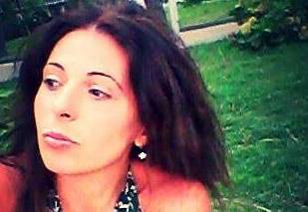 **CV**

**NINO METREVELI**

**Personal info**

First name Nino

Second name Metreveli

Date of birth 26.04.1981.

Place of birth Kutaisi, Georgia

Residential address 24, Dimitri Kipiani str, Kutaisi

Mob. 571283004

e-mail: [nmetreveli81@yahoo.com](mailto:nmetreveli81@yahoo.com)

**Education**

1999-2005 A. Tsereteli State University , Medical Therapy Faculty

1988-1998წ. St. Nino Gymnasium. ( Secondary School No.3, Kutaisi)

**Work Experience:**

From 2017 ( part time) St. Seraphim Saroveli’s Clinics , Kutaisi

Doctor - cytologist

From 2012 to present LTD “ Morphologist”:

Doctor – cytologist

May, 2021 LTD “ Bomond, Clinic Laboratory

Weiser

2009-2012 Kutaisi Oncology Center

Doctor – cytologist

2008-2009 United Nations Georgian Association (UNAG)

Imereti Office , Coordinator of Social and

Healthy lifestyle researches

2007-2008 International Center for Caucasus Tourism, ICCT

NGO, organizer of the training devoted to

healthy lifestyle

2006-2008 Kutaisi Republican Hospital

Residential Program “ Laboratory Medicine”

Laboratory Doctor Assistant.

**Training**

2016. Union of Cytotechnologists Pathologists

Certified two months Course.

Granted the permission to work as

an independent cytologist in the

field of cervical pathologies (PTJ,

2015 Seminar in Kazbegi

"Modern Diagnostic Approaches in

Practical Pathological Anatomy".

2014 International Center for Caucasus Tourism

Tbilisi, training "Healthy lifestyle through tourism"

2013 Association of Georgian Cytologist and Pathologists

Tbilisi, Training “Endocrinology Pathology and

                                         Neuropathology”

**Languages:**

Georgian Native

Russian Good

English Good

**Computer skills:** MS Office, Internet

**Interests:** Scientific and Art Literture, theatre, music, culionary

**Features of character:** Responsible, communicative, energetic, friendly, punctual.