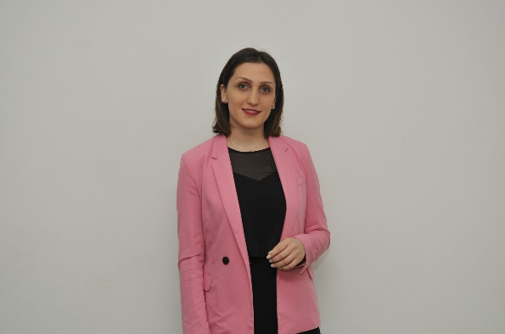Sesili Tabatadze

Date of Birth: 04/03/1991

Phone number: +995 598 54 05 88

E-mail: [sesili.tabatadze@gmail.com](mailto:sesili.tabatadze@gmail.com)

**Education:**

* Bachelor’s degree - Faculty of economics and business - Iv. Javakhishvili Tbilisi State University;
* Master's degree - Faculty of economics and business - Iv. Javakhishvili Tbilisi State University;
* PhD student - Faculty of economics and business - Iv. Javakhishvili Tbilisi State University;

**Working Experience:**

* Senior Auditor – State Audit office of Georgia – Since 2014
* Operator - LEPL Public Service Development Agency - 03.2014 - 06.2014

**Computer Skills:**

* Microsoft Office Word, Microsoft Office PowerPoint, Microsoft Office Outlook, SQL, Microsoft Office Access , Microsoft Office Excel

**Languages:**

* Georgian
* English

**Training and Certifications:**

* LEPL State Audit Institute - Financial and compliance audit
* LEPL - Institute of Public Audit, Productivity Improvement in the Public Sector
* LEPL - Institute of Public Audit, State Procurements
* TWINNING project - Analysis of audit data using IT
* State Audit Office - IT Audit Training (SQL)
* State Audit Office - Excel training
* Professor George Tsereteli, the 60th anniversary of the birth of the international scientific practical conference"
* "The 3rd Interuniversity student scientific conference";
* “TSU Business Olimpics 2012”
* “TSU Business Olimpics 2011”
* “Agriculture priorities for sustainable development”
* “70 th University Research and Business Conference”
* Business Planning & Management" - Association of Young Economists of Georgia;
* “Job search and self-presentation skills traning”- The International Organization for Migration.

**Labours:**

* The Impact of the Covid-19 pandemic on the tourism industry in Georgia
* Analysis and evaluation of state projects, which are about environmental protection
* Inventory and its results’ impacts of the financial accounts
* The role of the State Audit Office in the socio-economic development of the country
* Agricultural Insurance in Georgia
* Gross Domestic Product Analysis in Georgia

**Other Activities:**

* Course - “Summer School Program about History of America”
* Project - “Students of social enterprise support”- The Strategic Research and Development Center