Personal Information | TAMAR BAKRADZE
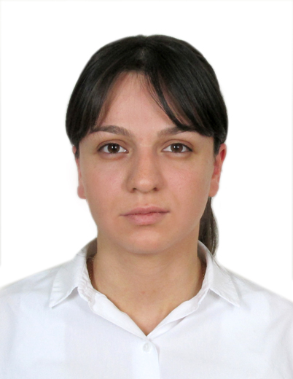 |   N18, 26 Maisi str. Kutaisi, lane 2, Georgia

0431244268  +995 571 453045

tamubaqradze@yahoo.com

https://www.facebook.com/tamu.baqradze
 | Sex: female | Date of birth : 30/04/1990 | Citizenship: Georgia

Education

1996-2007  2007-2013  2017- 2019 | Kutaisi St. Nino Public School N3  Kutaisi Akaki Tsereteli State University, faculty of healthcare (General Medicine), Certified physician  Akaki Tsereteli State University Faculty of Medicine, Master of Public health

Languages

Native Language | Georgian
Other Languages | understanding |  | SPEAKING |  | WRITING
Other Languages | Listening | Reading | Spoken interaction | Spoken production
English | C1 | C1 | C1 | C1 | C1
Russian | C2 | C2 | C2 | C2 | C2
 | English- good, Russian-Fluently

Personal skills | Aimed, punctual, communicable, creative, leader

Computer skills | Microsoft Office Word- very good  Microsoft Office Excel- very good  Microsoft Office PowerPoint- very good  skype/facebook/mail and other internet sites – very good

Experience
2018 (April) - present
Organization | Medical Corporation “Les Laboratoires Servier”
Occupation | Medical sales representative

2014 (March) - 2018
Organization | Medical Corporation “Novator Pharma “
Occupation | Regional manager

2008-2009
Organization | Company ‘’TV-LINE’’
Occupation | Sales manager

2010-2013

Organization | St. Pantanasa Center of Mamology and Oncology at Maternity House N3
Occupation | PR manager

Trainings and Courses of Certification
Leaning facility | Learning courses (Training) | Period (year) | Duration of leaning courses
Advertising Company ‘’TVLINE’’ | Public relation | 2006 | 3 months
St. Pantanasa Center of Mamology and Oncology at Maternity House N3 | Public relation | 2013 | 3 months

