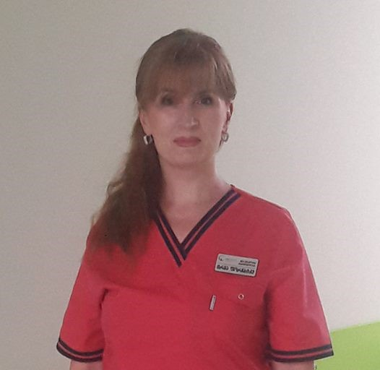 |  |  |  |  | Irma  Porchkhidze
 |  |  |  |  | Data: 12.10.2020  Khatuna Rusadze  ქუთაისის უნივერსიტეტი | Tsereteli st № 13  Kutaisi, 4600
Birth date: 06.02.1970
Education:
- Saratov State Medical University, Medicine (Russian Federation) 1989-1995
- Saratov State Medical University, Obstetrics and ginecology 1995-1996
- Learning course in reproductology, Saratov regional center for family health and reproduction 1996
- I.Zhordania Institute of Human Reproduction, Learning course in reproductology 2000
- Teachers (trainers) program, accredited by Ministry of Health, Labour and Social Affairs of Georgia. Medical Corporation EVEX and DTMU training center 2016
Work place:
- Tkibuli multi-profile hospital - 1996-2012 obstetrician-gynecologist, reproductologist
- „EVEX clinices “ Tkibuli Clinic since 2012 obstetrician-gynecologist, reproductologist
- „Khonelidze Clinic“, Kutaisi since 2016 obstetrician-gynecologist, reproductologist

Agmashenebeli st 7
Kutaisi 4600
 |  |  | +995 593256036
 |  |  | porchkhidzeirma@gmail.com
Personality Traits
Colleagues would describe me as a communicative, motivated, active and disciplined person. I like team work, which is an inseparable part of medicine. I am interested in starting my career as a lector in your university, I think its a great opportunity for professional and personal development. I hope my proposal will help your administration and will help students overcome the challenges of education.

Activities, Destinations

- Consultant with 18 years of experience in family planning and group consultations
- Conducting lectures in sexual education and reproductive health issues in public schools
- The Best Reproductive Health Office- UNFPA 2002
- The first place for successful delivery in family planning services- JSI Research and Training Institute 2008

Scientific works, topics:
- “Gestational Diabeties“- Saratov State Medical University, department of Obstetrics and Gynecology, Report on the International Congress of Obstetricians and Gynecologistsб 1996
- „Family Planning: Difficulties, challenges and positive moments“- topic: JSI Research and Training Institute 2008. First place

Learning programmes and trainings
- Learning course on reproductology- State Medical Academy of Postgraduate education 2000
- Family planning, Counseling and Reproductive health workshop - A Johns Hopkins Program for International Education in Reproductive Health 2001
- Learning course on Reproductive Health I.Zhordania Institute of Human Reproduction 2002
- Service marketing for health care providers training - Johns Hopkins University Center for Communication Programs 2002
- Gestosis in pregnancy- State Medical Academy of Postgraduate education -2004
- Climacteric syndrome- Georgian State Medical Academy 2004
- Hemotransfusion-Alllogeneic Tissue Transplantation- Georgian State Medical Academy 2004
- Reproductive health -- UNFPA Georgia 2005
- Chronic venous insufficiency from its early manifestation to trophic ulcers- Georgian State Medical Academy 2002
- Consulting, methods of contraception and Prevention of infection- JSI-Research and Study institute 2006
- Ante - and postnatal observations- evidence review-JSI- Reasearch and Study Institute
- Short course on reproductive health Andrology- UNFPA Georgia2009
- WINDOWS XP, Microsoft Office(WORD, EXCEL),INTERNET- PC learning senter of Tkibuli 2011year
- „Effective perinatal care” training course- USAID SUSTAIN 2012
- Long-term hormonal contraception Implanon insertion- USAID SUSTAIN 2013
- Team response to medical emergencies- Boston University Medical Center 2015
- Advances in Ultrasound in Obstetrics and Gynecology- Ian Donald School of Medical Ultrasound 2015
- International congress on Pathophysiology of Pregnancy- Ian Donald School of Medical Ultrasound 2015
- Obesity from childhood to Old Age-Association for the study of obesity of endocrinologists of Georgia 2016
- Teachers (trainers) program - EVEX learning center 2016year
- Family planning training package- Virtual Contraceptive Consultation2017
- The Second international conference on primary care development- EVEX medical corporation 2017
- Antenatal care- BMJ learning2018
- Antenatal Care-TSMU 2018
- The basic principles of fetus condition intranatal assessment -Association of obstetrician-gynecologists and perinatologists of Georgia2018year
- Antenatal testing of the condition of the fetus, identification and management of the pathological condition- EVEX Medical Corporation 2019
- Israel-Georgia conference in obstetrics and gynecology- Tbilisi 2019
- Antenatal Care- EVEX Hospitals 2020
- Pregnancy hypertensive disorders: pre-eclampsia, eclampsia, gestational hypertension, chronic hypertension, HELLP syndrome-diagnosis and management- EVEX Hospitals 2020
- Infertility 35+ -Georgian-German Reproductive Center 2020
-

Sincerely: Irma Porchkhidze
12.10.2020

