Sergo Chakvetadze
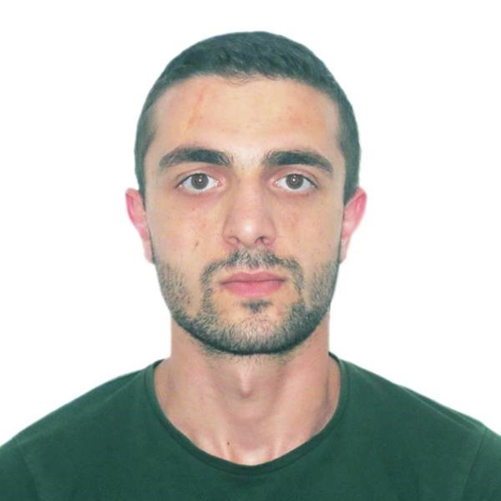
M.Aslanikashvili st. N 6/8  Kutaisi  Tel: 599 08 80 39  sergichakvetadze@gmail.com

Education
- 2014-2018 – Akaki Tsereteli State University
- Faculty – Business, Law and Social Sciences
- Field of Expertise – Finances, Banking and Insurance
- Academic Degree - Master

Work Experience
- 2019.12. – Present – Kutaisi University
- Position – Assistant Professor
- Duties – Lead the learning process
- 2016.10. - Present – Microfinance Organization “Crystal”
- Position – Junior Internal Auditor
- Duties: compliance and effectiveness audit;
- 2018.09. – 2019.01. – Georgian-American School “Progress”
- Position - General Director’s Business Advisor
- Duties:
- Analyzing business related revenues and expenses;
- Analyzing and assuming internal control mechanisms;
- Assisting General Director in the managing process.
- 2018.09. – 2019.01. - Georgian-American School “Progress”
- Position - Coach of Business Skills course
- Duties: organizing and managing studying process.
- 2015.06.-2017.12. – Kutaisi Municipality Mayor Office
- Position – Leading Specialist at Administration Division.
- Duties:
- Preparing and presenting state purchasing documents;
- Dealing with suppliers;, preparing and presenting balancing documents;
- Controlling fulfillment of contractual terms;
- 2015.04.-2015.06. – Revenue Service of Georgia
- Position – Intern of the Tax Monitoring Department
- Duties:
- Participating in monitoring process.
- 2013.01.-2015.01. – Research Intellectual Club “Dialogue of Generations”
- Position – Organization’s member, projects coordinator
- Duties:
- Participating in organization’s activities;
- Coordinating projects and programs;
- 2014.03.-2014.07. – Youth Involvement Center
- Position – Project’s Manager
- Duties: projects planning and fulfillment.
- 2014.02.–2015.04. – State Audit Office of Georgia
- Position – Intern
- Duties: participating in financial, compliance and effectiveness audit.

Trainings
- 2018.07.05. – Fire-fighting and Evacuation;
- Georgia’s Labor Security and Health Care Association.
- 2017.10.-2018.02. - Taxing
- Business Academic Center.
- 2018.01.-2018.07. - Auditing (F8)
- Georgian Federation of Professional Accountants and Auditors.
- 2018.01. – Intensified Ms Excel Course
- Education, Development and Employment Center.
- 2017.07.-2018.01. – Management Accounting (F2)
- Georgian Federation of Professional Accountants and Auditors.
- 2017.01.-2017.07. – Accountant in Business (F1)
- Georgian Federation of Professional Accountants and Auditors.
- 2017.01.-2017.07. – Financial Accounting (F3)
- Georgian Federation of Professional Accountants and Auditors.
- 2014.12.-2015.03. - Financial Accounting
- Business Academic Center.
- 2014.03.-2014.03. – Youth Able to live sustainable
- European Commission - Youth Exchange Program in Armenia.
- 2013.09.-2013.10. – Story of Citizenship
- European Commission - Youth Exchange Program in the Ukraine.
- 2013.07.-2013.08. – Different Countries Same Problems
- European Commission - Youth Exchange Program in the UK.

Skills
- Languages:
- Georgian - Native;
- English - FCE B2/IELTS 6.5;
- German - A2;
- Russian – A2.
- Office Programs:
- MS Word - Good;
- MS Excel - Good;
- MS PowerPoint - Good;
- Edocument - Good;
- Ms Outlook - Good;
- Personal Skills:
- High sense of responsibility;
- Hard-working;
- Details Oriented;
- Punctual;
- Sociable;

