Personal information | Nodari Maglaperidze
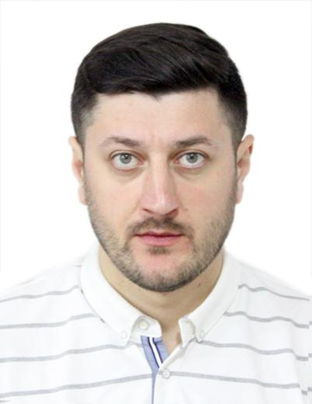 |   Georgia,Kutaisi, Javaxishvili str. N13/32

0431244268  +995 577 626753

maghlaperidzenodari@yahoo.com

Facebook : https://www.facebook.com/nodo.maglapheridze
 | Sex: Male | Date of birth 07/12/1989 Citizen Georgian

education

1996-2007  2007-2013  2017-2019 | Kutaisi Akaki Tsereteli N1 classic gymnasium  The Medical Faculty,Akaki Tsereteli University (Kutaisi)  Master of Health Care Policy and Management of Akaki Tsereteli University Faculty of Medicine.

languages

Native language | georgian
Other languages | UNDERSTANDING |  | SPEAKING |  | WRITING
 | Listening | Reading | Spoken interaction | Spoken production
english | C1 | C1 | C1 | C1 | C1
russian | C2 | C2 | C2 | C2 | C2

Personal skills | Skillful, Sociable, Punctual, Creative, Leading Skills, Ability to Work in a Stressed Environment

Computer Programs | Microsoft Office Word-Fluently  Microsoft Office Excel-Fluently  Microsoft Office PowerPoint-Fluently  skype/facebook/mail and other internet programs-Fluently  EIDSS - Electronic Integrated Disease Surveillance System  NCDC - Logistics module

Experience at local level
2011-2016 Unified National Examination Center - Curator
2012-2013 United Water Supply Company of Georgia - Service Agent
2014-present Kutaisi "Public Health and Safety Environment Center"Main specialist.
2017-2020 2017-present Clinic "Beaumond" - Polyclinic Manager
2018-2020 National Center for Disease Control – state programs coordinator
2019-present Ak.Tsereteli State University – invited lecturer
2019-present Kutaisi University - Invited Lecturer
2020-present LTD ,,LJ and Company – West Georgia Tuberculosis and Infectious Disease Center” -
Chief physician

Trainings, seminars, congresses.
2012 year Training "Basic Managment of Health"
2013 year Training "Modern Concepts of Health Management"
2018 year Training “Clinical Manager Training Course”
2019 year Scientific Conference - "Modern Advances in Clinical Medicine"

