***CURRICULUM VITAE***

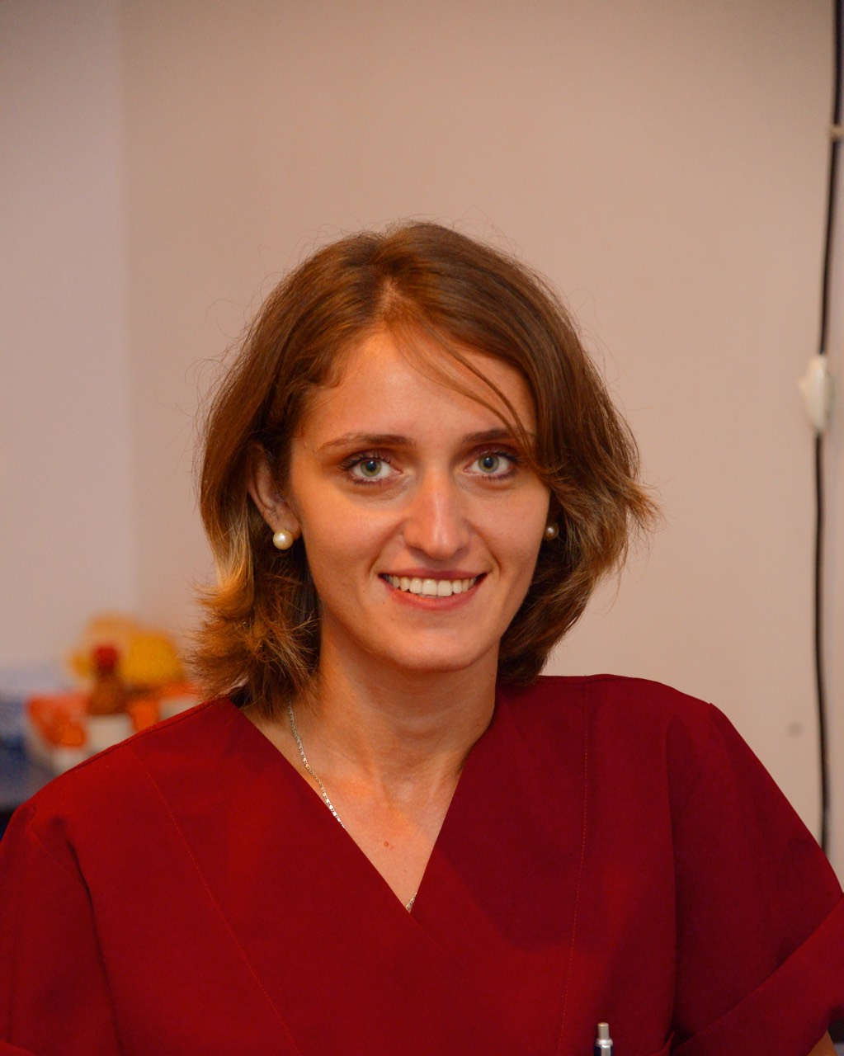

***DATUASHVILI LANA***

*Address: Georgia, Kutaisi Tabukashvili street 92/28*

*Phone: +995 593 337 558*

*E-mail:* [*datuashvili.lana@yahoo.com*](mailto:datuashvili.lana@yahoo.com)

*National Representator of Young Ophthalmologists from Georgia at SOE (European Society of Ophthalmology) – SOE YO committee member, Newsletter Editor.*

***EDUCATION:***

***MASTER DEGREE*** *IN OPHTHALMOLOGY AT KHARKOV MEDICAL ACADEMY OF POSTGRADUATE ADUCATION 2011- 2013*

***BACHELOR DEGREE*** *AT TBILISI STATE MEDICAL UNIVERSITI 2005-2011*

***20.12.2013 WAS GRANTED AS A SPECIALIS IN GEORGIA – OPHTHALMOLOGITS* *STATE CERTIFICATE***

*FROM 2016 –* ***PHD DEGREE*** *OF AKAKI TSERETELI STATE UNIVERSITY – CHEMICAL SCIENSE AND MEDICAL PHARMACOLOGY.*

***EDUCATION OF OTHER INSTITUTIONS:***

***SUMMER 2010 ANKARA, TURKEY*** *– PRACTICAL COURSE HUJJETEPE UNIVERSITY.*

***SUMMER 2010 GEORGIA*** *– PRACTICAL COURSE IN SACHKHERE MEDICAL CENTER.*

***SPRING 2013 KIEV*** *– PRACTICAL COURSE IN THE CENTER OF DIAGNOSTIC AND TREATMENT*

*‘RETINOPATHY OF PREMATURITY’.*

***11.05-18.05.2014******AUSTRIA, VIENNA*** *– PRACTICAL COURSE IN HANUSCH HOSPITAL.*

***02.11.2015-30.11.2015 GERMAN, BERLIN*** *– PRACTICAL COURSE IN CHARITE UNIVERSITY – IN PEDIATRIC AND OCULOPLASTIC SURGERY*.

***16.05.16-16.06.16 TBILISI, GEORGIA*** *- PRACTICAL COURSE IN OCT – AVERSI CLINIC.*

***29.04.18-11.07.18 NETHERLANDS*** – PEDIATRIC AND STRABISMUS FELLOWSHIP IN ROTTERDAM EYE HOSPITAL.

***10.02.2019-22.02.2019 MINSK, BELORUS*** – NEW APPROACHES IN LACRIMAL TRACT TREATMENT/SURGERY.

**25.12.2019-17.01.2020** – SRI SANKARADEVA NETHRALAYA, INDIA – TRAINING IN PHACOEMULSIFICATION.

***EMPLOYMENT:***

***2011-2013 KHARKOV*** *OPHALMOLOGICAL KLINIK #14 L.L. HIRSHMAN FROM*

***2014- CLINIC ‘LJ’*** *KUTAISI GEORGIA - OPHTHALMOLOGIST*

# *FROM 2014 – West Georgian National Center of Interventional Medicine – OPHTHALMOLOGIST – ROP specialist.*

***FROM 2016 – RONIKO OPTICS*** – OPHTHALMOLOGIST

***From 2020*** – Self-Employee, founder of – Eye Office, Kutaisi, Georgia.

***FROM 2018 – LECTURER IN ATSU*** (AKAKI TSERETLIS STATE UNIVERSITY)

***From 2020*** – **Invited Lecture in Kutaisi University**, Georgia

***CONFERENCE PROCEEDINGS:***

***24-25.05.2012 (23-24.05.2013)******ODESSA, UKRAINE*** *- PARTICIPANT OF INTERNATIONAL SIENTIFIC-PRACTICAL CONFERENCE IN OPHTHALMOLOGY ‘FILATOVE’S READING’*

***15.06.2012******KHARKOV, UKRAINE*** *– PARTICIPANT OF KHARKOV REGIONAL CONFERENCE OF OPHTHALMOLOGISTS*

*‘CURRENT ISSUES OF OPHTHALMOLOGY’*

***12.12.2012 (13.03.2013)******UKRAINE, KHARKOV*** *– REGIONAL MEETING PARTICIPANT – SOCIATY OF OPHTHALMOLOGISTS*

***12 -13.06.2014******BUDAPEST, HUNGERY*** *– ROP WORKSHOP - ‘The Structure, Screening and Anti-VEGF Therapy for Retinopathy of Prematurity in Georgia' (presentation).*

***13-20.07.2014(13 -20.07.2015) ITALY*** *– VENICE OPHTHALMOLOGY SUMMER SCHOOL 2014 (VOSS 2014) - ‘Late complications of ROP’ (presentation).*

***23.03.-27.03.15 AUSTRIA*** *– SALZBURG MEDICAL SEMINARS.*

***10.02-11.02.2017 MADRID, SPAIN*** *– 1st INTERNATIONAL SWEPT SOURCE OCT & ANGIOGRAPHY CONFERENCE –* *‘BRENCH RETINAL ARTERY OCCLUSION’.*

***10.06.17-13.06.17 BARCELONA, SPAIN*** *– EUROPEAN SOCIETY OF OPHTHALMOLOGY CONGRESS – EL. POSTER PRESENTER.*

***24.08.17 – 26.08-2017 YEREVAN, ARMENIA –*** *ROP MEETING – ROP SCREENING AND TREATMENT STATISTICS IN IMERETY REGION - POSTER PRESENTER.*

***22-23.12.2018 TIOC*** *(Tbilisi INTERNATIONAL OPHTHALMOLOGY CONFERENCE) – ROP (CLINICAL CASE).*

***19-21.04.2019 ISTANBUL, TURKEY*** *- BSOS (Black Sea Ophthalmology Meeting)* ***–*** *Poster Presentation – Complication of Strabismus Surgery.*

***13.06 -16.06.2019 NICE, FRANCE*** – *EUROPEAN SOCIETY OF OPHTHALMOLOGY CONGRESS – EL. POSTER PRESENTER – COMPLICATIONS OF STRABISMUS SURGERY.*

*06.11.2019-10.11.2019 – ANTALYA, TURKEY – SURGICAL TIPS FOR YOs – presenter.*

***PRESENTATIONS OF PROFESSIONAL CONFERENCES:***

*I.Pastukh. I.Soboleva. N.Goncharova. L.Datuashvili. M.Chvisuk Secondary IOL implantation in rehabilitation of children with Aphakia// Abstract book BSOS ESCRS Academy meeting, Tbilisi, Georgia 2013.*

*I.Pastukh. I.soboleva. N.Goncharova. L.datuashvili. M.Chvisuk Secondery IOL implantation in*

*rehabilitation of children with Aphakia//Materials of the 111th Congress of the German Society of*

*Ophthalmology, Berlin, 2013.*

***01.01.2014-01.01.2015 ARVO Foundation*** *- “The long term follows up of Avastin treated ROP – Refractive changes”.*

***LENGUAGES: ENGLISH*** *– WELL* ***GEORGIAN*** *– NATIVE* ***RUSSION*** *– WELL*

***COMPUTER SKILLS****: WORD –WELL POWERPOINT –WELL EXCEL – PROFICIENT INTERNET –WELL*

**List of Publications: Iplastics *-* Asia Pacific Society of Ophthalmic Plastic & Reconstructive Surgery - Tearful Tear Trough: Anatomy, Grading and Management** **Vol.** 5 Issue 1, January 2020 Eyelid Issue

**My surgical experience:**

1. Strabismus surgery – 100 (recession, resection, tenotomy, transposition of the muscles)
2. Cataract surgery – 50 (40 phacoemulsification, 10 SICS)
3. Ptosis – 5 (as an assistant)
4. Chalazion – 150
5. Pterygium – 130
6. Blepharoplasty – 30
7. Externa DCR – 3
8. Vitreo-Retinal Surgery – 10 (as an assistant)
9. Glaucoma – 30 (assistant)
10. Corneal Transplantation – 1 (assistant)